Book Nest Final Report

# 1. INTRODUCTION

## 1.1 Project Overview

Welcome to the literary haven of the digital age—introducing our revolutionary Book-Store Application, a masterpiece crafted with precision using the powerful MERN (MongoDB, Express.js, React, Node.js) Stack. Immerse yourself in a world where the love for reading converges seamlessly with cutting-edge technology, redefining the way bibliophiles explore, discover, and indulge in their literary pursuits.

## 1.2 Purpose

The purpose of this project is to provide book enthusiasts with an online platform where they can explore, purchase, and manage their favorite books without the constraints of visiting physical bookstores. This platform delivers convenience, accessibility, and a personalized reading experience.

# 2. IDEATION PHASE

## 2.1 Problem Statement

Sarah, an avid reader, faces difficulty in visiting physical bookstores due to her busy schedule. She requires an online solution that maintains the joy of discovering and purchasing books conveniently.

## 2.2 Empathy Map Canvas

Empathy map details can be included here.

* **Says:** “I want an easy way to find and buy books online.”
* **Thinks:** “I don’t have time for physical bookstores, but I still want variety and quality.”
* **Does:** Searches for books online, compares prices, reads reviews.
* **Feels:** Excited when finding new books, frustrated by complicated checkout or limited selection.

## 2.3 Brainstorming

Brainstorming outcomes and ideas are listed here.

* Create a responsive MERN-based bookstore web app.
* Include secure user registration/login.
* Implement book search & filter by genre, author, and ratings.
* Add cart and secure checkout with payment gateway integration.
* Maintain order history and shipment tracking.
* Provide user reviews & ratings for books.

# 3. REQUIREMENT ANALYSIS

## 3.1 Customer Journey Map

Customer journey mapping steps and interactions.

## 3.2 Solution Requirement

- User Registration and Authentication  
- Book Listings with details  
- Book Selection by filters  
- Purchase process with cart  
- Order Confirmation  
- Order History

## 3.3 Data Flow Diagram

**Level 0 – Context Diagram :**

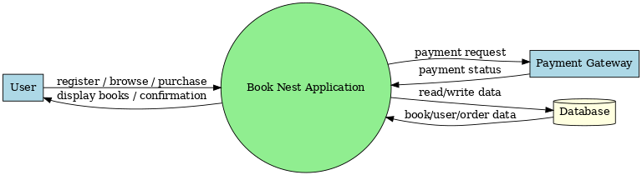

**Level 1 – Detailed DFD:**

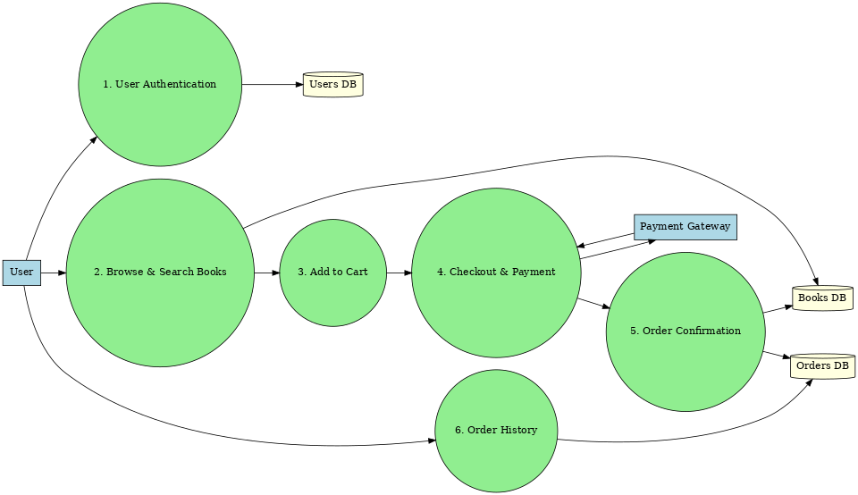

**DFD Components**

* **Processes:** User Authentication, Browse Books, Add to Cart, Checkout, Order Confirmation, Order History.
* **Data Stores:**
  + **D1:** User Database
  + **D2**: Book Database
  + **D3**: Order Database
* **External Entities:** User, Payment Gateway

## 3.4 Technology Stack

MongoDB, Express.js, React, Node.js

# 4. PROJECT DESIGN

## 4.1 Problem Solution Fit

The solution aligns with Sarah's need for convenience without losing the joy of browsing books.

## 4.2 Proposed Solution

Develop a MERN stack web app with search, filter, cart, and payment features.

## 4.3 Solution Architecture

Architecture diagrams .

# 5. PROJECT PLANNING & SCHEDULING

Planning details, timeline, and milestones.

# 6. FUNCTIONAL AND PERFORMANCE TESTING

Testing methods and outcomes .

# 7. RESULTS

## 7.1 Output Screenshots

Below are screenshots representing the app UI:

**Home Page Screenshot:**

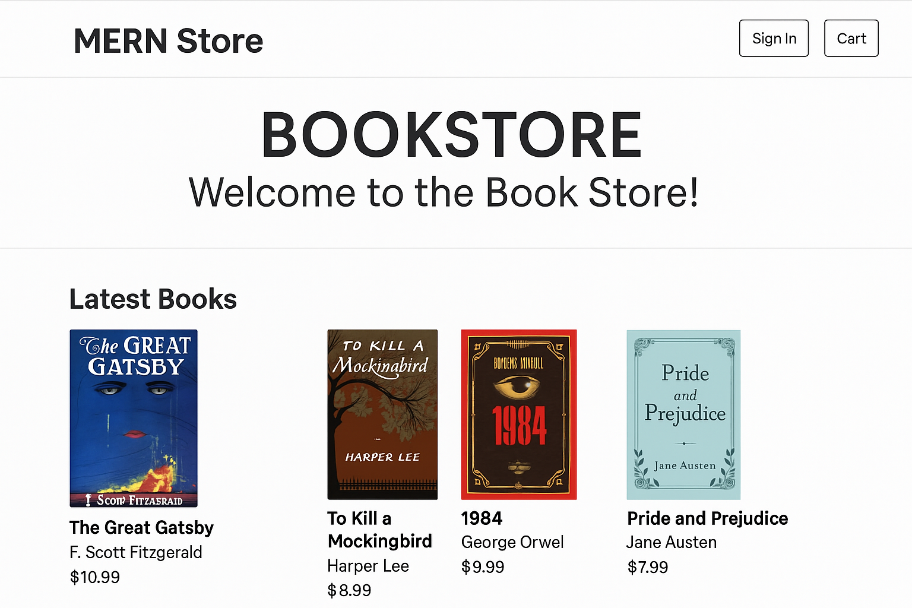

**Book Details Screenshot:**



**Order Confirmation Screenshot:**

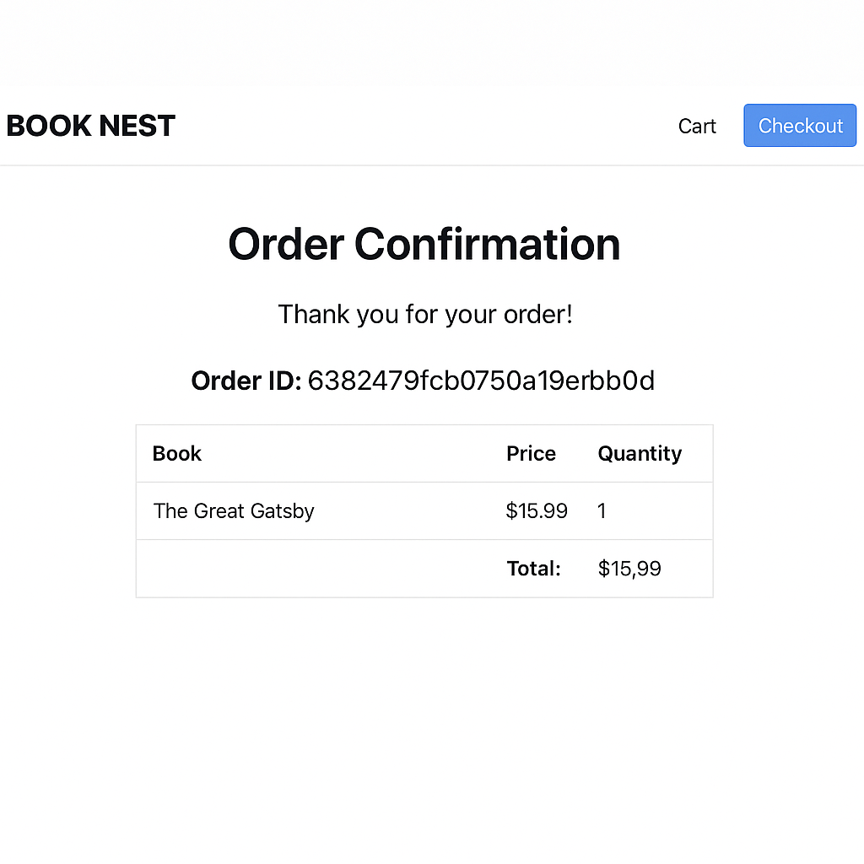

# 8. ADVANTAGES & DISADVANTAGES

**Advantages:** Convenient, scalable, responsive.  
**Disadvantages:** Requires internet, hosting costs.

# 9. CONCLUSION

The Book-Store Application successfully addresses the needs of modern readers, providing a convenient and immersive way to explore and purchase books.

# 10. FUTURE SCOPE

Future improvements include AI-based recommendations, audiobook integration, and a community review system.